

Downloading Solidworks eDrawings Viewer:



Follow the big red arrows…

Go to “Solidworks.com”…


Then “Products” and click on “Free CAD Tools”…



Click on “Download eDrawings Viewer FREE”…

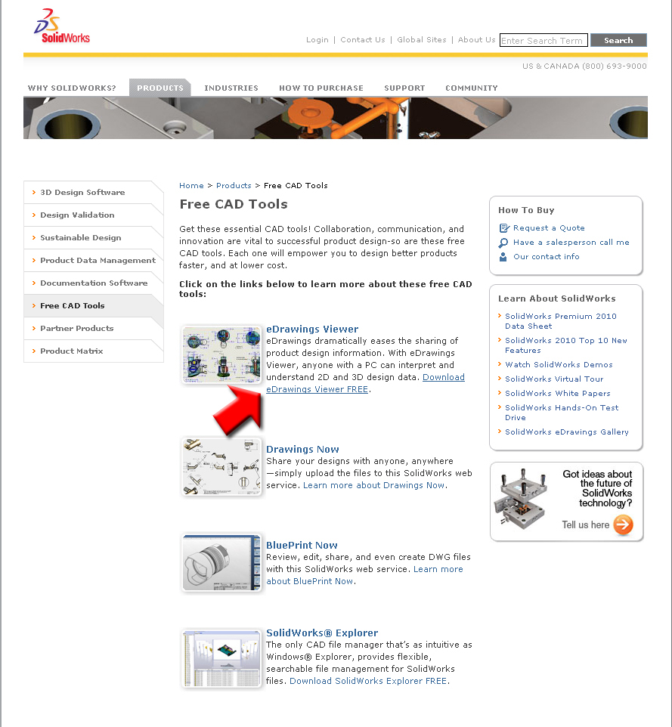

Click on “eDrawings”…
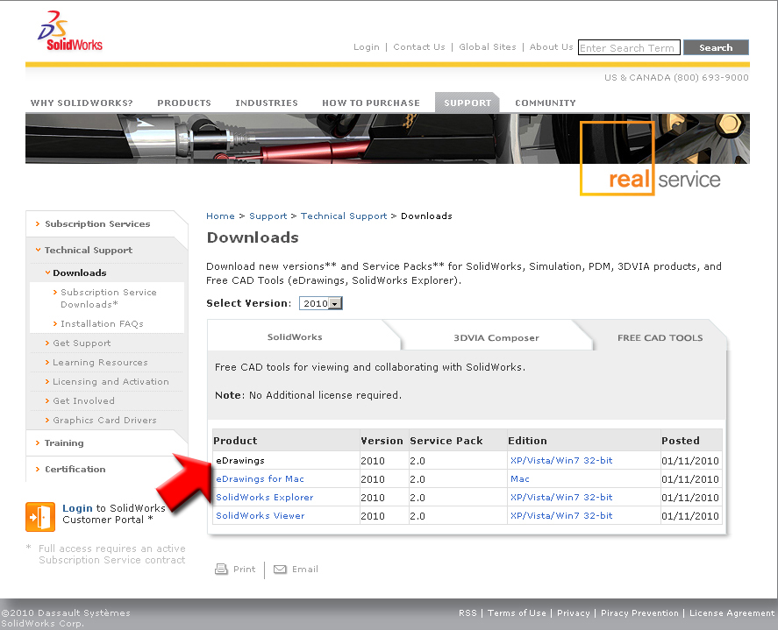

Select “eDrawings Viewer Only” and click “Next”…
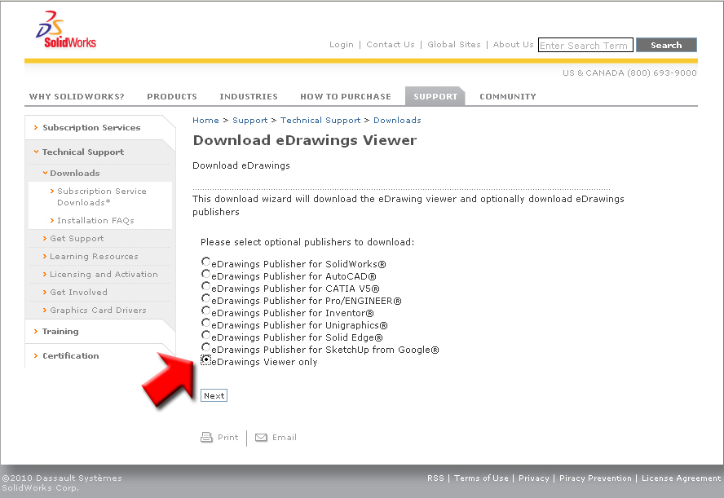

Select a language and click on “Download”…
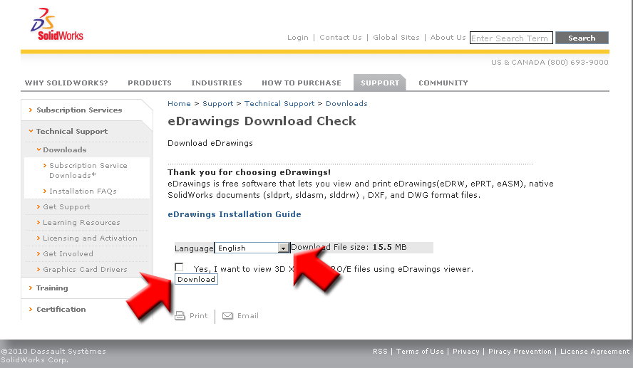

Select “I confirm the accuracy of the statements above” and click “Accept Agreement & Continue”…
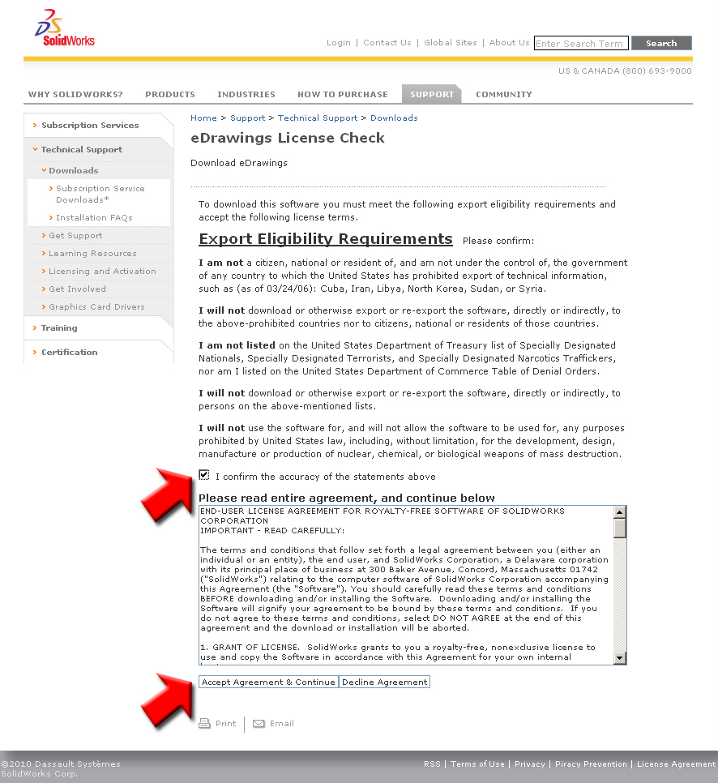

Click “Save File”…
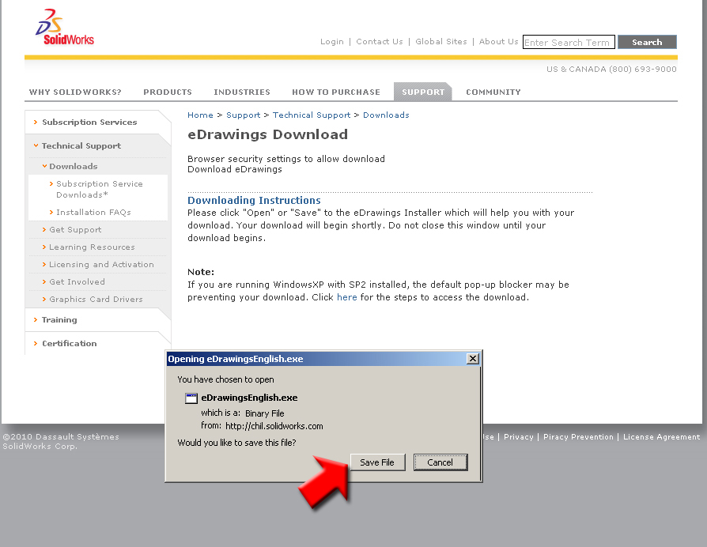

Save the file to your computer and run as any other program. Once you do you will be able to open eDrawings files. These are very convenient since they are small 3D files.

